Shabbos Stories for
Parshas metzora 5782
Volume 13A, Issue 33 - 8 Nisan 5782/April 9, 2022
Printed L’illuy nishmas Nechama bas R’ Noach, a”h

For a free subscription, please forward your request to keren18@juno.com
Past stories can be found on the website ShabbosStories.com

My Grandmother, a Sephardi Lioness
By Cassandra Freeman

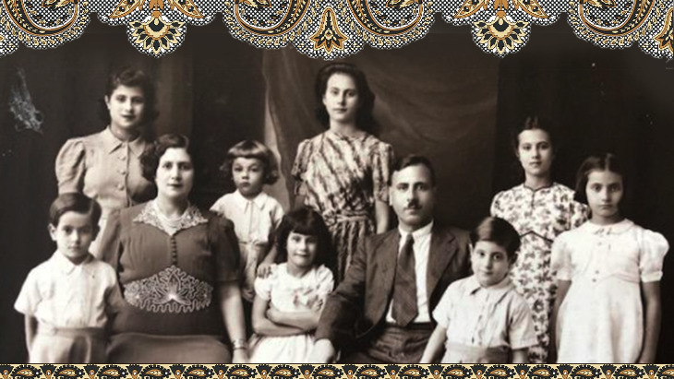
From Baghdad to Bangalore to Vancouver, I can still hear her desert call in the wind.

My grandmother would do a ‘desert call’ – a loud high-pitched cry – at major celebrations. It was always a playful reminder of my heritage. I grew up hoping she’d unleash the call as I walked down the aisle at my wedding.
No, my grandmother wasn’t Bedouin. She was a proud, fierce and warm-hearted Sephardic Jew who kept her identity intact as she moved from Baghdad to Bangalore to Vancouver during her lifetime.
She had many names. Kamal was her Arabic name; Serach was her Hebrew name and Sarah Moses was the name she used most often in Canada. Her 11 sons and daughters referred to her affectionately as “the general”.

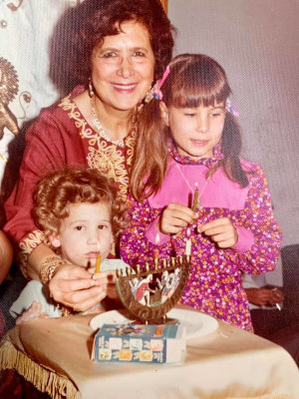
Kamal with two great grandchildren

I remember a very colorful matriarch with gold bangles, rings, earrings and red hair always intact. In her nineties she’d clap and sing to recordings of Sephardi prayers and watch Hindi and Arabic videos.
She’d host dinners for two dozen on Passover, Rosh Hashanah and Friday nights, bargaining with the shopkeepers to get the prices. She once bargained with the manager for the best price on a watermelon. I was embarrassed until I realized that they were both having a great time.
Whenever I throw food out today, I hear my grandmother’s voice admonishing me in Arabic: “Whee! Machlel!” Translation: “It’s a sin.”

Founders of a Vancouver Synagogue
My grandparents were two of the founders of the Beth Hamidrash synagogue in Vancouver, Canada. I remember sitting beside my mother and grandmother listening to ancient Sephardic chants and prayers. It felt as if I were back in time when all of world Jewry lived in the Middle East or Spain. It was magical but it wasn’t exotic. It was simply who we were.
When she was well into her eighties my grandmother ordered the men upstairs to pray so that the women could meet downstairs. No one dared question the general! She commanded attention when she needed to, in spite of never learning to read or write. She even gave advice to the mohel at one of my nephews’ bris. The rabbi present told him to listen to what she said.
When the Turks occupied Iraq, my grandmother was a teenager working in her father’s store. When she saw Turkish soldiers coming to demand money, Kamal would courageously slip the cash into her apron and walk out as the Turkish soldiers came in.
So, it didn’t really surprise me when my mother told me that my grandmother played with snakes when she was a child. Kamal’s grandmother Samra had a pet snake that she would leave to guard a new baby in the house. When Samra returned the snake would be arched and ready to attack anyone who came near the cradle.

Saw Relatives in Her Dreams
Kamal’s relatives came to her in her dreams. She could also sense when a friend or relative was ill almost before they did. And she called to see if she could help.
She could also see a joyous occasion before it was ready to happen. When I first started dating my husband Irwin Levin when I was 34, she soon started asking me questions like: “Where’s your husband today? Will you see him tonight? Where are you going with your husband tomorrow?”

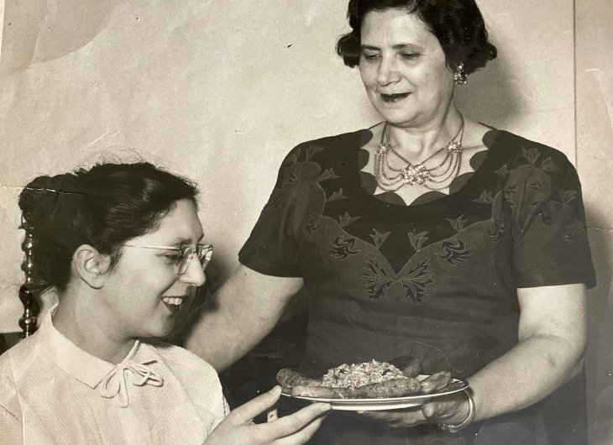
My grandmother married her husband when she was 15. The marriage was arranged but my grandmother had chosen him when they were still children.
My grandfather Guergi (George) would walk down the street to visit Kamal and her chaperones on the Sabbath. As is still the custom of some Iraqi Jews, he would wear his pajamas. It is, after all, a day of rest.
She married my grandfather and her first two children were born in Baghdad. Soon after my grandfather was thrown in prison and beaten up for a crime he did not commit. The Jewish community rallied together and hired a British lawyer.
As soon as grandpa was home, the young family left Baghdad to start a new life with relatives in Bangalore, India. It was sometime during the late 1920’s that my grandfather began selling clothes, with horse and carriage in his new city. My grandmother designed clothes and my grandfather eventually opened another store.
My grandmother gave birth to 16 children. Eleven lived.
Every two years or so there was another child to feed. My grandmother gave birth to 16 children. Eleven lived: six girls and five boys in that order. My mother Joyce was girl number five.
She remembers looking out of the top window of the store watching Mahatma Gandhi or Gandhije – as his followers knew him – walking by with a parade of people around him, in direct defiance of the British occupation.

It was an exciting time for the family. Prime Minister Nehru would come to the store when he visited Bangalore. My grandmother, with children and a servant in tow, once visited the Maharaja’s son to present him with clothing that my grandmother designed for his mother.

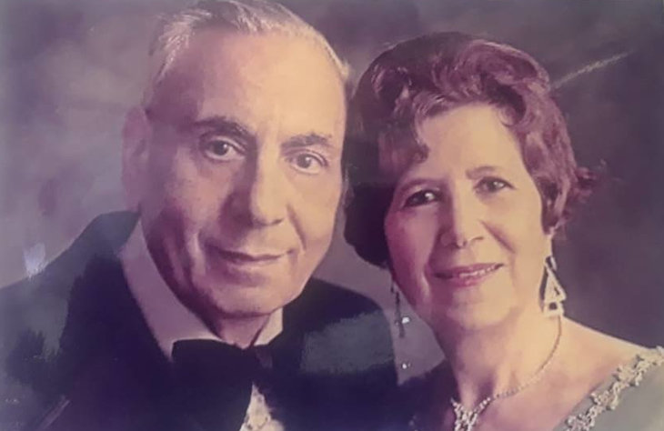
My grandparents

Hindu and Muslim friends would come by the store as well.
And even though the family thought the British occupation was a disgrace, my grandmother regularly cooked Shabbat dinner for the British and American Jewish soldiers. Kamal was also a great matchmaker. One of the soldiers married an aunt.
After the civil war the family moved to Vancouver, Canada where my grandparents learned to start yet again and opened another store. For years, they were part of a small but growing and vital Sephardic community.
My grandfather died when I was 23. My grandmother died when I was 39. She was well into her 90’s. My husband and I were married six months later outside the Beth Hamidrash synagogue.
There were no ‘desert calls’ at my wedding. But both my mother and I sensed Sarah Kamal Moses’ presence on that day. For me, it was as if her spirit was at one with the wind – playfully dancing in and around the poles of the brightly decorated chuppah.
A version of this article originally appeared in The Jewish Independent newspaper.
Written with contributions from the Moses family.

Reprinted from the March 7, 2022 website of Aish.com

The Lesson Behind the Uncertified Mailing of
A Large Cash Donation

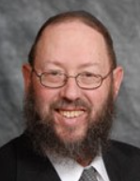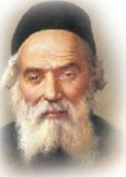
Rav Yissocher Frand and the Chofetz Chaim

Rav Yissocher Frand once related a story he saw in Otzros HaTorah. “One time, the person who took care of the finances for the Radin Yeshivah came to the Chofetz Chaim carrying a plain envelope that was sent through the Polish Postal System. The envelope contained five hundred rubles in cash.
We have to assume that the postal system in Radin around 1920 was no better than the current postal system in the United States, and yet, nobody today would put five hundred dollars cash in uncertified mail and expect to see it arrive at where it is supposed to arrive.
The Chofetz Chaim asked his secretary to find out the story behind this envelope. Who puts five hundred rubles in an envelope in the mail without even bothering to get it certified?
The assistant learned the following story: A certain business man was trying to make a business deal. He pledged, ‘If this deal is successful, I am going to give five hundred rubles to the Chofetz Chaim’s Yeshivah.”
The deal ended up being successful, but it was late in the afternoon, and the post office was already closed. He reasoned that he would simply send it out the next day. But then he heard a little voice in his head that said, ‘Five hundred rubles? Do you not think the Yeshivah would be happy to receive fifty rubles? Of course, they would be happy with fifty rubles! Why do you need to send five hundred rubles?’ The man said, ‘I saw my determination dissipating, and I was afraid that if I would wait until the next day, it would become five rubles. I determined, that no matter what, I was going to stuff the money into an envelope and drop it into a mail box, without any certified mail or return receipt, because I saw that if I would wait any longer, the enthusiasm and determination to do the Mitzvah would evaporate!’”

Reprinted from the Parshas Tzav 5782 email of Rabbi Yehuda Winzelberg’s Torah U’Tefilah.

The Story of the Irreligious Jewish Doctor Ben (the Son of) An Irreligious Jewish Doctor

The Kozhnitzer Maggid would tell the following story. There once lived a Jewish doctor who scorned the Torah and did many Aveiros. He successfully encouraged his son to follow in his ways, however, his wife managed to get the boy to commit to perform one Mitzvah— the Mitzvah of Netilays Yadaym, and he agreed to always wash his hands before he ate any meal that included bread.
Though he grew up to be as irreligious as his father, the son took his mother’s words to heart and would only eat bread if he washed first, even though sometimes this meant that he would spend an entire day starving before his first meal. The son became a doctor like his father, and one day, he got entangled in a dispute, and was summoned to Bais Din.

The Dayan is Forced to
Excommunicate the Young Doctor
When the Dayan issued his decision in favor of the other party, the young doctor felt this was unjust, and he proceeded to ridicule and ignore the Dayan’s ruling. Left without any other choice, the Dayan reluctantly wrote a notice of excommunication, forbidding anyone to come in contact with the doctor. The young doctor dismissed this too with arrogance, for he didn’t care much about the Jewish law.
Around the same time, the young doctor prepared to set out on a journey. Part of the way included a dangerous, a long stretch of road that went through a forest, where packs of bandits were known to stay, and they would wait for people passing through to rob. Because of this, travelers would get together and go through as a group, before they would enter the woods. However, because of the ban, the young doctor had trouble finding fellow travelers. He asked many merchants if he could join their caravans, but they all ignored him because of his excommunication.

Forgot to Bring Along Water to Wash for His Bread
Desperate to finally leave, he decided to purchase a fast horse and set out on his own. As the young doctor rode through the forest, he realized that he had forgotten to bring water along. Finding a river was too dangerous now, but it also meant he wouldn’t be able to eat the bread that he took. The young doctor urged his horse forward in desperation, as pangs of hunger kept increasing. He only slept when exhaustion finally took him over.

Many times, he thought of reaching into his bag and eating the bread, but he never brought himself to actually do so. Even though he was suffering from hunger, the young doctor was too frightened to gamble with his life to try and find some water. On the fourth day of his journey, he heard the sound of rushing water, and he found himself in front of a swiftly moving river.
The young doctor began to swing off his horse, and then he felt his heart stop. Just on the other side of the riverbank, bandits were assembling on horseback. Two thoughts went through the young doctor’s mind. He could either wash his hands now and risk being killed, or swing back onto the horse and escape. But the young doctor’s hunger made him delirious, and he quickly ran to wash his hands.
The bandits saw him and immediately headed his way, and the young doctor began racing back to his horse. He had just opened his bag with the bread in it, when a bandit struck him. The young doctor fell, bleeding from a wound. The other bandits closed in around him, and they beat and robbed him. After they took everything he had, they left him to die, and soon after, his Neshamah ascended to appear before the Heavenly Court in Shamayim.
Before anything was said in Bais Din, the Mitzvah that the young doctor had just performed, Netilas Yadayim, appeared before the Malachim, and related the young doctor’s dedication to the Mitzvah, and insisted that he should be admitted immediately into Gan Eden. The Malachim accepted this argument, and the young doctor was escorted to the gates of Gan Eden.

Returns to the Rav in a Dream
However, the Malach standing at the gate was blocking his way. He said, “You were excommunicated during your time on earth, and I cannot let you in. Go back to the Rav who put the ban in place, so he can reverse it.” That night, the young doctor appeared to the Rav in a dream, and informed him of his predicament.
The Rav did not want to delay the Neshamah from entering Gan Eden, and he removed his decree. When the young doctor again went to the gate, the Malach still would not let him in. He said, “Just as your excommunication was in writing, so it must be when it is reversed. Also, request for the Rav to arrange a Jewish burial for your body.”
The young man again appeared to the Rav and made his requests, and he agreed to publicly annul the ban first thing in the morning. He also reassured the young doctor that his body would be found and buried by the next group of merchants that left the city. One thing caught the Rav’s attention. As he spoke with the young doctor, he realized that the young man had a deep understanding of the Torah and its teachings. The Rav asked how the young doctor had learned such knowledge, since during his life he was very removed from anything Jewish.
The young doctor replied, “Before I went up to Shamayim, the Malach that was created from my sacrifice to fulfill the Mitzvah of Netilas Yadayim, taught me the entire Torah.” The Kozhnitzer Maggid would teach from this story that we can learn from it the immense value and spiritual power of even a single Mitzvah!

Reprinted from the Parshas Tzav 5782 email of Rabbi Yehuda Winzelberg’s Torah U’Tefilah.

A Meal for Eighteen Strangers

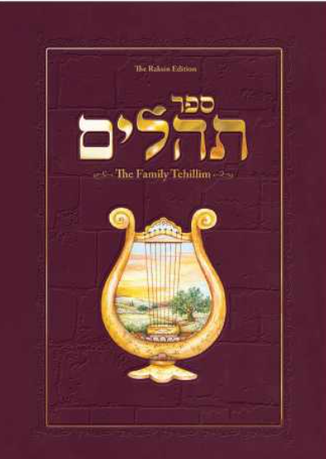

One day, Yaakov Rechimi (the grandson of Rabbi Michael Peretz of Mexico), received a phone call from a man who wanted to invite him to a seudat hodaya, a thanksgiving celebration that one hosts when one experiences a miracle. The caller told him his name, which community he belonged to, and which synagogue.
Yaakov thought he recognized the name, but he didn't really know the person and wasn't sure why he was invited. Still, he said: "Of course, you invite me to a seudat hodaya, I will come. What is it that you want to thank HaShem for and celebrate with a meal?"
The caller tells him, "I almost passed away. One month I was in the hospital with Corona; I almost died. But I survived, thank G-d, so now I want to make a seudat hodaya."
So Rechimi said: "Of course I'll come," even though he still wasn't sure why he was invited. When he arrived at the host's home, he saw 17 other men were also present for the celebration meal. The 18 people including himself were a random group; each man was from a different shul, a different community, a different area. It just didn't click for him why this specific group of 18 people were there.
He remarked to the person next to him: "It's so nice that he invited us to his celebration." They started talking and the other man tells him that he has no idea why he was invited; he doesn't know the person who is making the seuda. "I got a phone call," he shrugged, "so I came."
Rechimi told him "Yes, the same thing with me. I don't know why I was invited, but I'm here." It turned out that all 18 at the table didn't know why he was invited and was puzzled.
Then, the person who the miracle happened to, who appeared to be about 60 years old, stood up and started speaking. "I know you all want to know the reason why I invited you. I'll tell you what happened.
"When I was lying in the hospital, basically dead from the Corona, I felt myself rising up to Heaven. The first one I saw there was my mother, who had passed away a few years before. She exclaimed, 'What are you doing here?! Go back down!'”
“I answered her, 'Ma, I want to go back down but I can't.'
"My mother waved off my answer. 'No, you can go down. You want to know why? Look down there -- just take a look!'
"So, I look down and what did I see? I saw all of you that I invited to this meal. You were in 18 different places but I saw you all in one glance while I was in Heaven. I saw you sitting saying Tehilim (Psalms) for me. In fact, at that moment every single one of you was mentioning my name and my mother's name. Even though you had no clue who I was, you mentioned my name and recited Tehilim for my complete recovery. "My mother then said to me 'You see, they are giving you the power to come back alive.' And that's what happened and that's why I invited every single one of you 18 people to the seuda. Because while I was in Heaven, I saw you saying tehilim for me and saving my life!”

Reprinted from the Parshas Tzav 5782 edition of the Lamplighter from Chabad House of Caulfield in Australia. Source: Yerachmiel Tilles from the report of Rabbi Peretz about the NDE experience of his grandson. Connection with Weekly Reading: Tzav provides the details of the Thanksgiving Offering (Levit. 7:11-15)

Last Ship from Nazi Germany

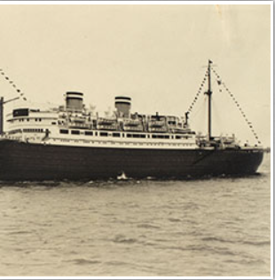

Life in Frankfort in the 1930s was like the morning before a thunderstorm - clear blue skies and a brisk breeze, with threatening gray clouds massed on the horizon and ominous rumblings of thunder in the distance. Nevertheless, the Jews of that city managed to maintain a normal existence, and their children for the most part enjoyed a carefree childhood. The famed Hirsch Realschule continued to educate children as it had for generations, while being careful to keep the Jewish children off the streets when the gentile children got out of school. In such a society did Berta, and her siblings grow up.
As the years passed and Hitler rose to power, many Jews attempted to leave Germany before it was too late. Although some managed to escape, it was soon clear that for the vast majority there were precious few places to run. The world was turning its back on the Jews. The wise teachers would say to Berta's class, "There is nowhere left for us to go. G-d is over us all. If He wishes to save us, He will."
Then came Kristallnacht.
Berta's father, a Polish emigre, was shipped to the concentration camp of Sachsenhausen, from where many never returned. Frantic, as their father's fate hung in the balance, Berta's family discovered that many detainees were being granted their freedom on the condition that they leave the country immediately. But where could they go? The doors of the world's great democracies were slammed shut in their faces.
Berta's family managed to obtain false Venezuelan visas, and thus armed, the 16-year-old Berta made her way to the SS headquarters to plead for her father's life. She was granted his freedom on the condition that he leave the country within 24 hours. Germany does not have many ports, however, and that day only one ship, the Orazio, was leaving the country from Hamburg. Berta contacted the shipping company in the hopes of securing place on board for the family, or at the very least for her imprisoned father, but the anti-Semitic shipmaster refused to allow a Jew on board. The desperate family pleaded for standing room in any corner available, even in the bathrooms, but to no avail.
Defeated, Berta returned the next day to SS headquarters, only to be greeted by an incredulous Nazi captain. "Are you still here?" he questioned, and then burst out laughing. "Your G-d must be watching over you. The ship that you did not board yesterday exploded as it left the harbor." Impressed with Berta's courage, he permitted the family to travel to Italy, where they boarded the Augustus, the last ship to leave Europe before Italy joined the war. As the ship steamed towards the unknown world of Venezuela, Berta once again repeated her teacher's wise words, "G-d is over us all. If He wishes to save us, He will."

Reprinted from the Parshat Vayikra 5782 email of Rabbi David Bibi’s Shabbat Shalom from Cyberspace.

A Time for Hakoras
Hatov (Gratitude)

Horav Chaim Pinchas Scheinberg, zl, was a Rosh Yeshivah, a Torah giant who achieved an extraordinary level of erudition in the entire Torah. His hasmadah, diligence in Torah, was legendary. His erudition was matched only by his level of hakoras hatov. He showered every person who benefitted him – regardless of faith – with gratitude for even the simplest, most basic and decent favour.
This was especially true if Torah benefitted as a result of a person’s generosity – material and emotional. (Yes, giving of one’s time and strength to help a Jew in need should be recognized, acknowledged and appreciated.) Rav Scheinberg had a good friend, Mr. Meyer Marlowe, who was a pharmacist living on the Lower East Side of New York.
Upon the Rosh Yeshivah’s recommendation, Mr. Marlowe served as the provider of medicines and medicinal supplies for the students and staff of Yeshivas Mir, which was located in Shanghai, China. They, together with other yeshivah men and families, escaped during World War II just as the Nazis were about to overrun their yeshivah.
Rav Shachne Zohn, zl, served as the liaison between the yeshivah and Mr. Marlowe. This represented much more than an act of generosity on Mr. Marlowe’s part. The medicines required meticulous, uniform packaging in order to pass muster with the Japanese (who controlled it until 1945) authorities. If a shipment that arrived did not meet their strict guidelines, it landed in the ocean.

Worked Long Overtime Hours
As a result, Mr. Marlowe worked long overtime hours, painstakingly packaging and seeing to it that they executed everything to perfection. All of this was without a fee. It was pure chesed, kindness at its apex. This was not a one-time endeavour. It went on for months; whenever the call came, he was prepared to help. Indeed, he viewed this as his special mitzvah to assist in the furtherance of Torah. Years passed, the war ended, and life was slowly returning to a sense of normalcy. Mr. Marlowe developed painful ulcers which, after a while, began to haemorrhage. Even today, with many drugs and procedures, this is a serious illness. Then, it was life-threatening. He was admitted to the hospital where he was treated for a number of months, during which time he required numerous blood transfusions to replenish the blood that he had lost due to hemorrhaging.
Regardless of the severity of the illness and station of the patient, only so much blood was available and everyone received an allotment. Mr. Marlowe’s allotment had reached its completion. The administrators of the hospital informed the family that they felt bad for them, but other patients were also in need of blood. They were halting Mr. Marlowe’s transfusions. This was essentially a death warrant.

In Dire Need of Blood Donations
The family immediately consulted Rav Scheinberg. He, in turn, called Rav Shachne Zohn and informed him that the individual who had given selflessly of himself to supply drugs to the Mir talmidim was in dire need of blood.
The very next day, in what was an extraordinary demonstration of hakoras hatov, a line formed from the hospital entrance, stretching around the block. The students of the Mir came en masse to repay their benefactor.
This was true hakoras hatov. They realised that his hard work and devotion to Torah played a critical role in their survival. True, he was Hashem’s shaliach, agent, but, obviously, Hashem had chosen him for his worthiness. He had modelled chesed for them.

Reprinted from the Parshas Tzav 5782 email of Rabbi A.L. Scheinbaum’ Peninim on the Torah.

The Rewards of Being a Shluchei Mitzvah

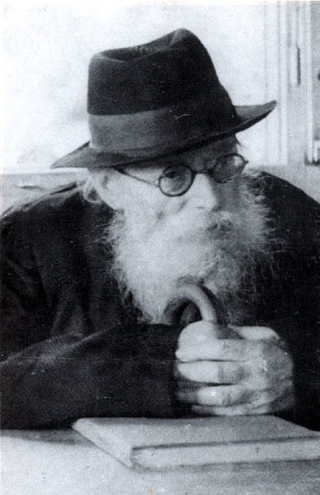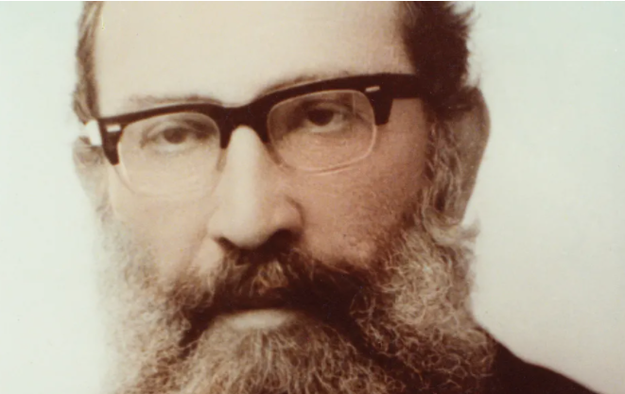
The Chazon Ish and Rav Shmuel Rozovsky

Rav Shmuel Rozovsky, ZT”L, Rosh Yeshiva of Mir, once traveled out of Yerushalayim to give a shiur (Torah class). On his way home, the car he was riding in was in an accident, and he was injured. Rav Shmuel wondered why he was injured, as we know that “Shluchei Mitzvah”, those that travel for a mitzvah, do not get hurt neither while traveling to nor returning from the place where the Mitzvah is accomplished.
He was reminded of a similar occurrence with the Chazon Ish (Rav Avrohom Yeshaya Karelitz), ZT”L, who had sent an emissary from Bnei Brak to repair a Mikvah in a nearby town. This messenger was injured in a car crash on the way home. The Chazon Ish was bothered by the same question, for he had sent the messenger to do a Mitzvah.
The Chazon Ish researched the particulars of the accident and discovered that things could have been a lot worse. Based on the speed of the oncoming car and other factors, the injuries should have been quite severe. Therefore, the Chazon Ish stated, the reason why my messenger was only slightly injured, and not seriously hurt, was only because he was on his way back from doing a Mitzvah.

Reprinted from the Parshas Tzav 5782 email of Mendel Berlin’s Torah Sweets Weekly.

